**Depth Classification Examples**

Brief Introduction

Left graph: Color image

Right graph: Depth image

3D Reconstruction: left -> right

Blue – close

White – far

Classify photos into 5 categories:

* Flip
* All-Blue
* Bad: Should be on one plane and no sudden color change, but large or sudden depth change(color change in depth graph)
* Sky-but-not-bad
* Good
  + Light effect – consistent ok
  + Window – consistent ok

1. Flip Examples - The ordering of the depth is completely flipped

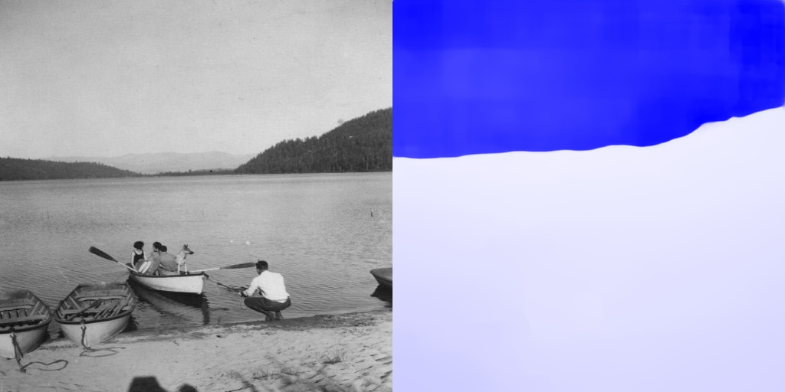

06803.jpg



07955.jpg

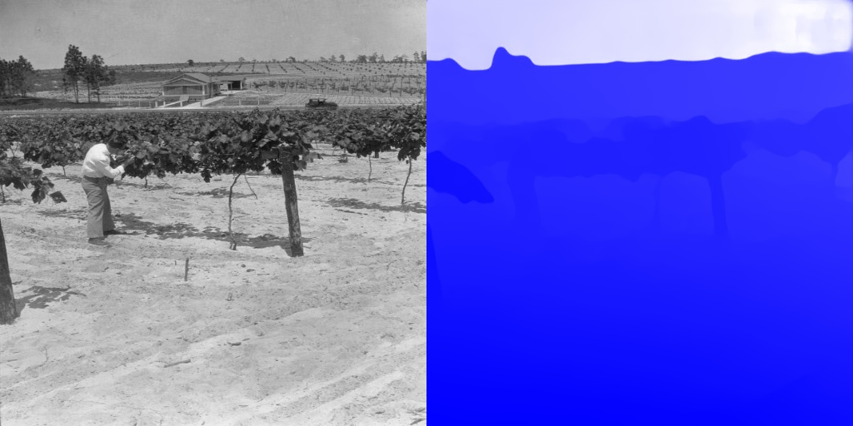

08449.jpg

1. All-Blue -- The Depth Image is not showing the depth at all

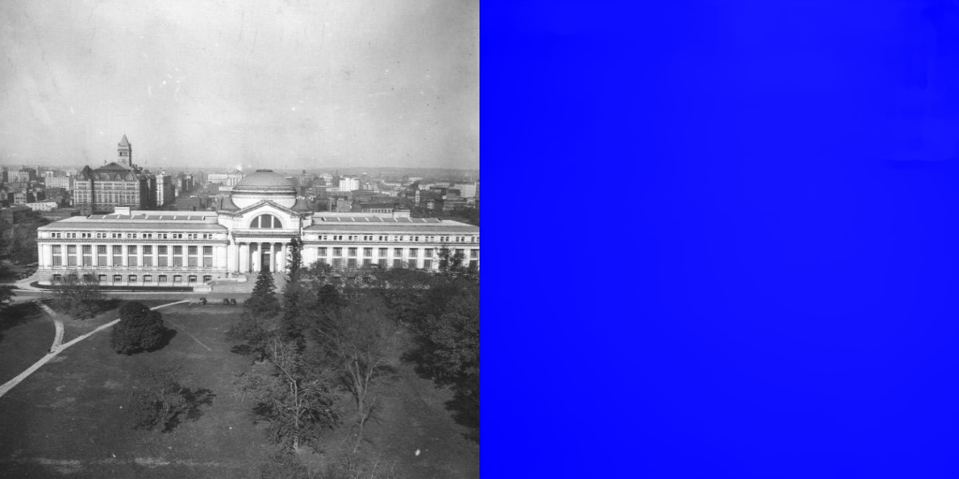

07199.jpg

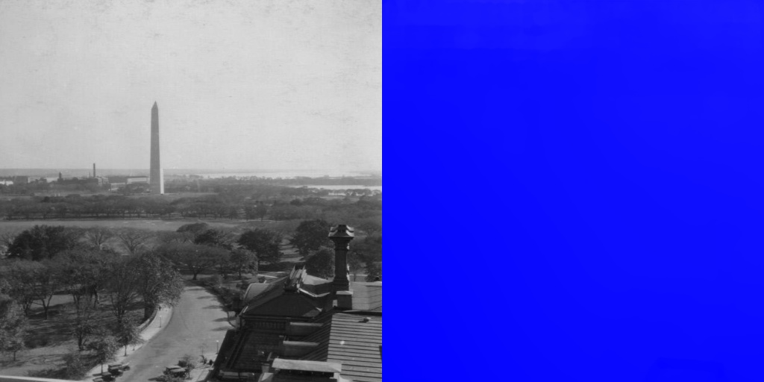

07381.jpg

1. Bad -- Depth Image is not consistent with its Color Image –

1) Weird color change: while the objects in the Color Image are on the one plane(same depth) and the objects have no sudden color changes, the Depth Image has its corresponding part with large or sudden color changes(depth change)

2) The ordering of depth is partly reversed: while the object A in the Color Image are closer to the camera than object B, object B is bluer than object A in Depth Image

1. Weird color change examples:

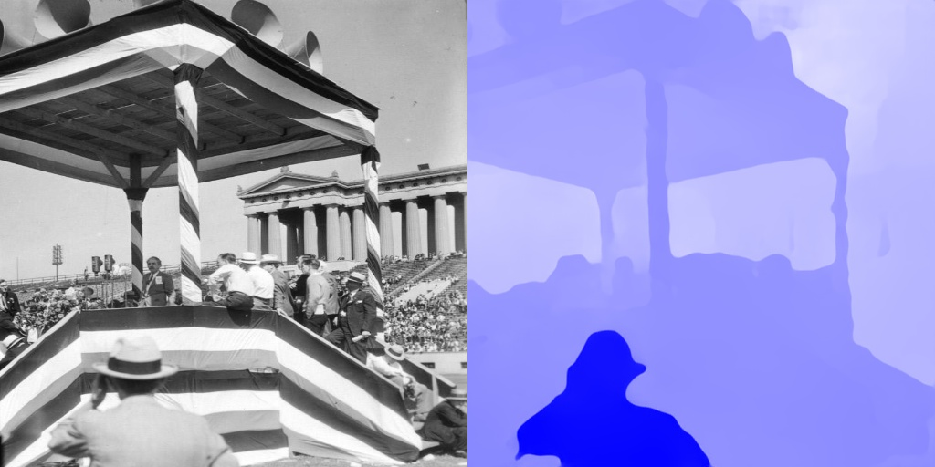

05211.jpg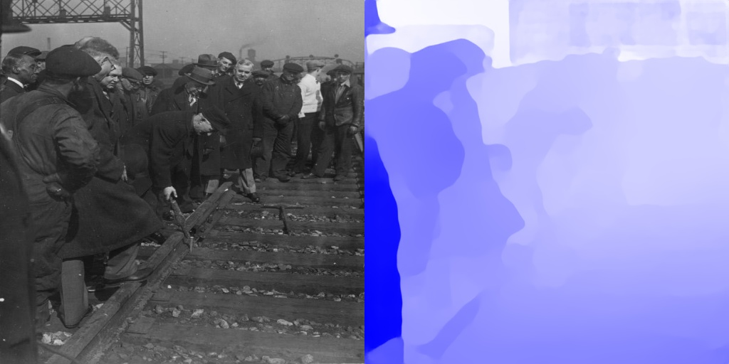

05295.jpg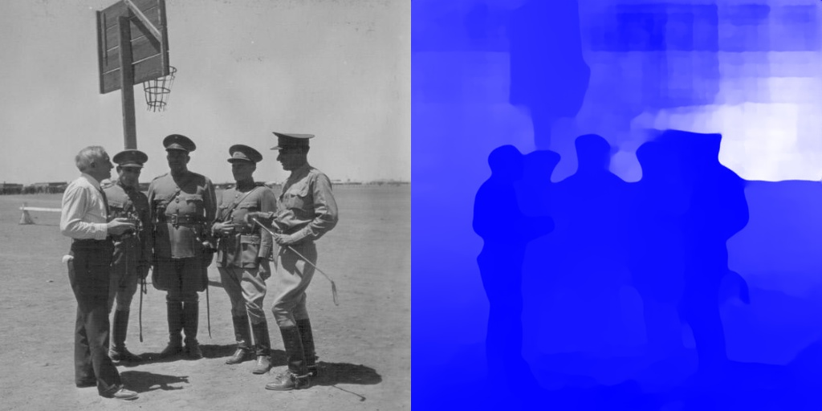

06249.jpg

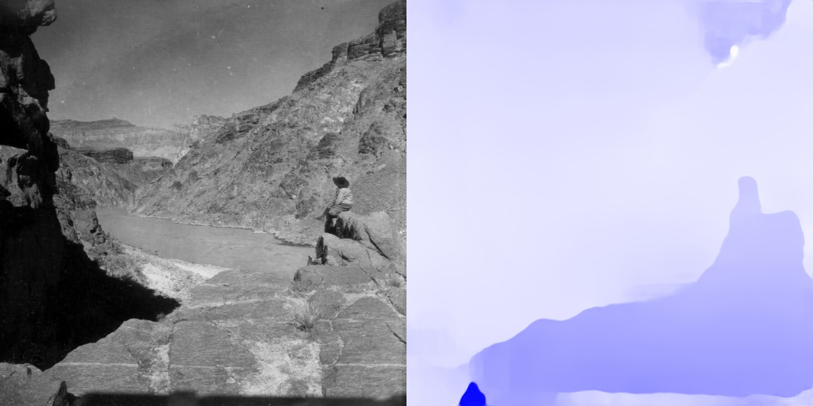

06475.jpg



06509.jpg

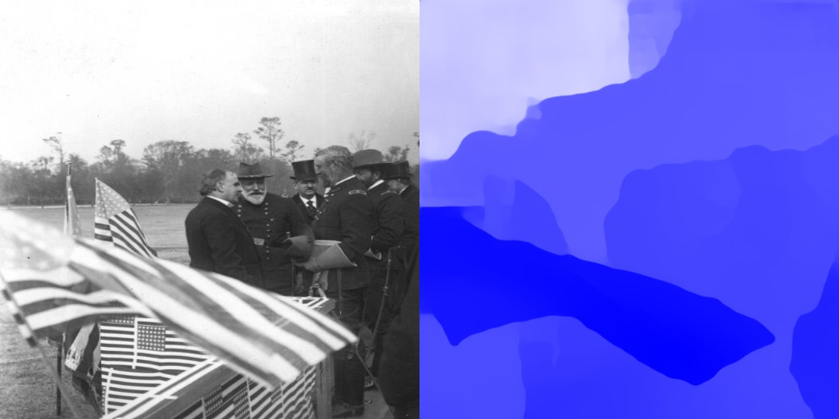

06931.jpg

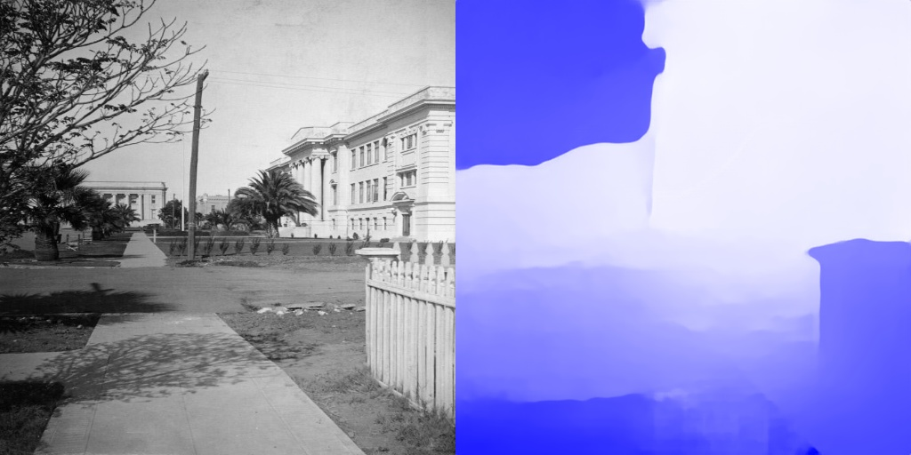

06829.jpg

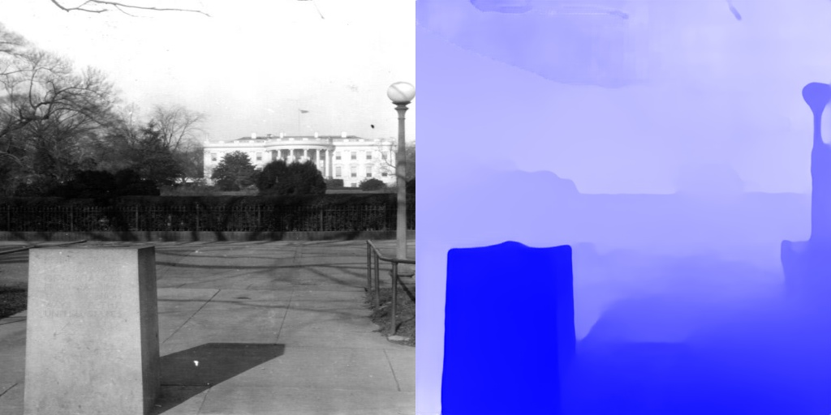

07257.jpg

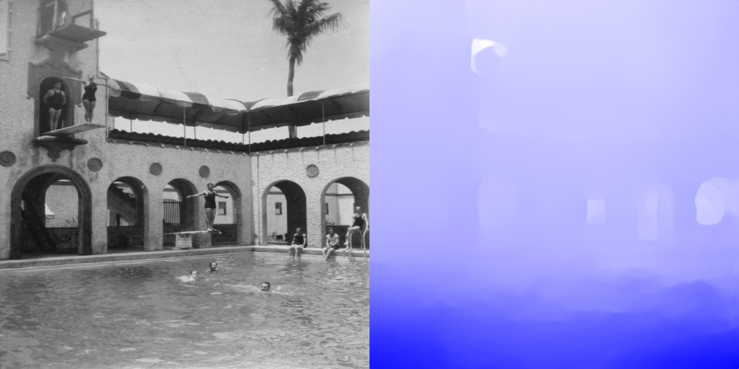

07877.jpg

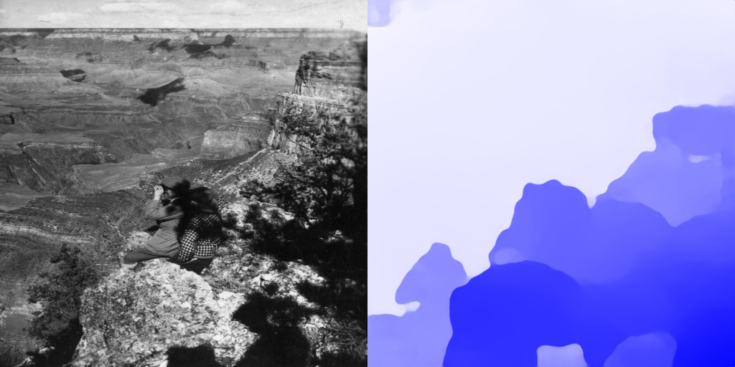

06477.jpg

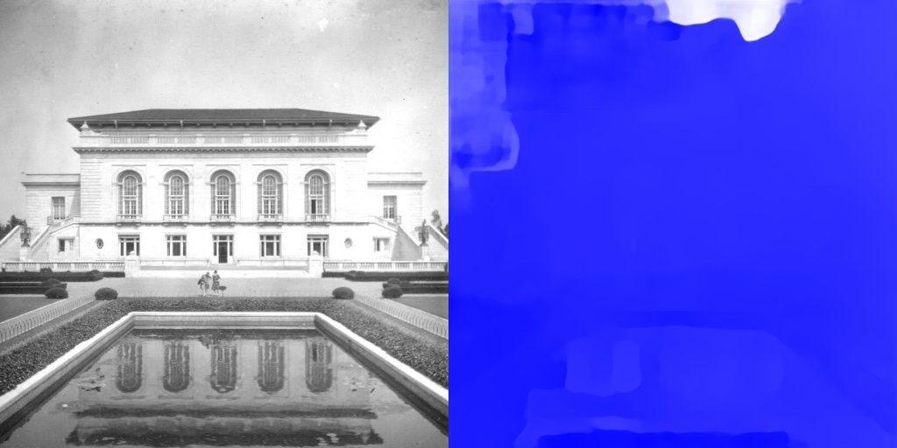

07215.jpg

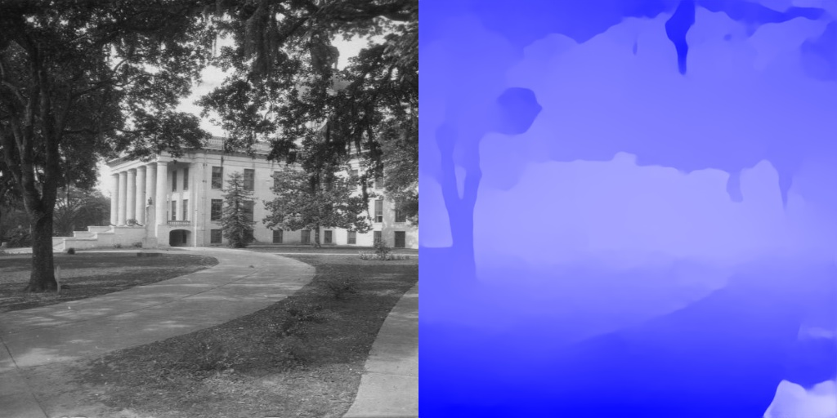

08143.jpg

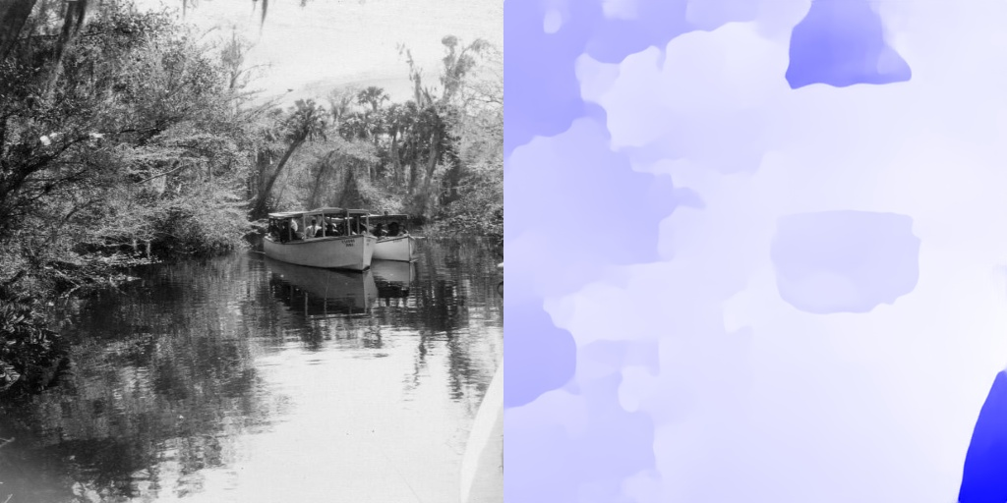

08425.jpg

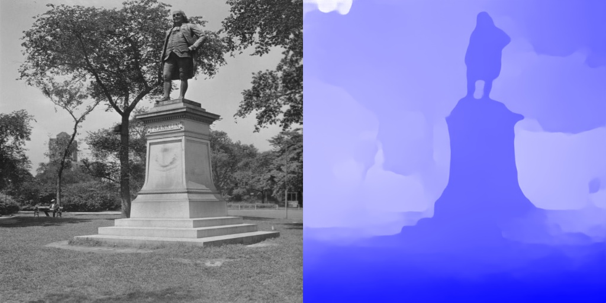

08945.jpg

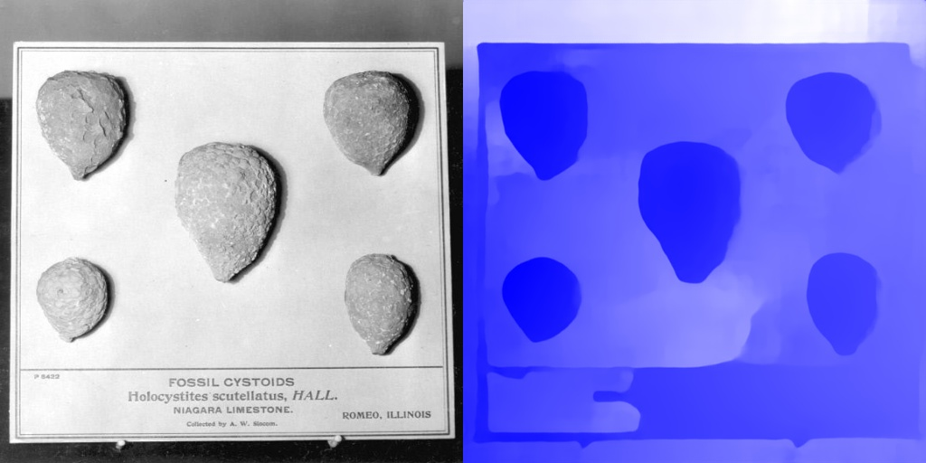

09183.jpg

1. The ordering of depth is partly reversed

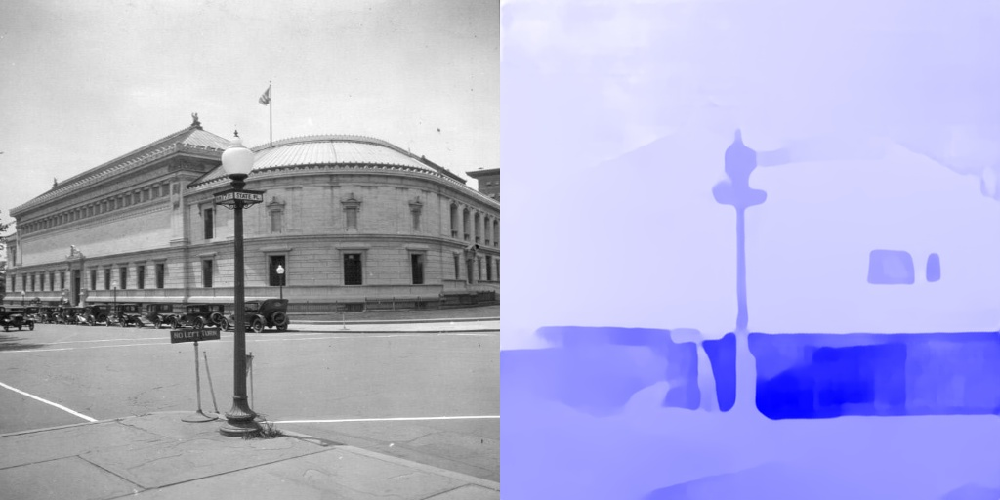

**Object A is Closer**

**Object B is further**

07099.jpg

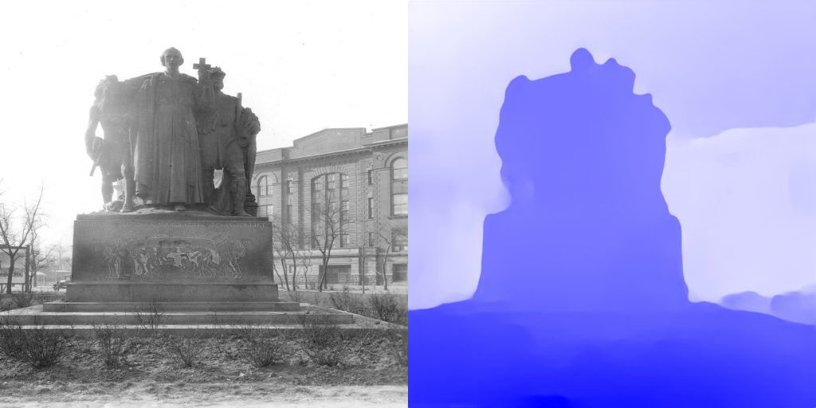

**Object B is further**

**Object A is Closer**

08707.jpg

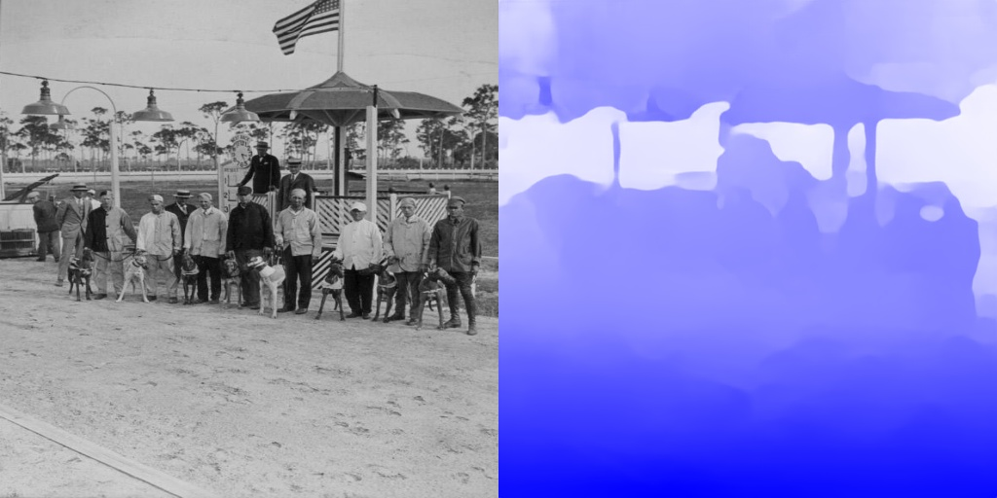

**Object A is Closer**

**Object B is further**

08379.jpg

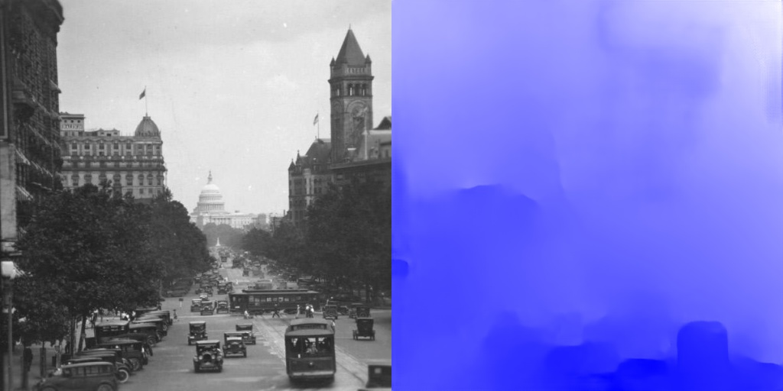

**Object A is Closer**

**Object B is further**

07411.jpg

1. Sky-but-not-bad -- The image was not classified as bad and the Depth image contains sky element(s)

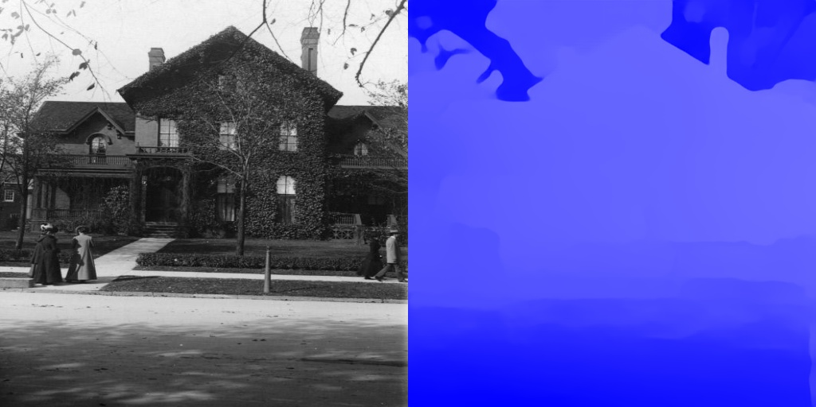

06311.jpg

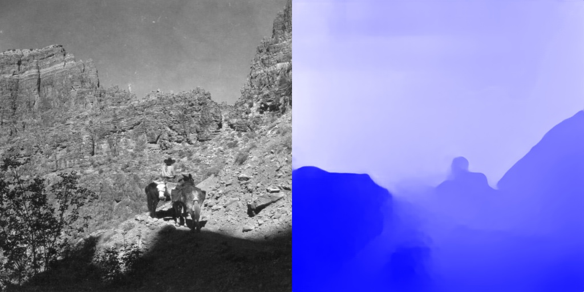

06497.jpg

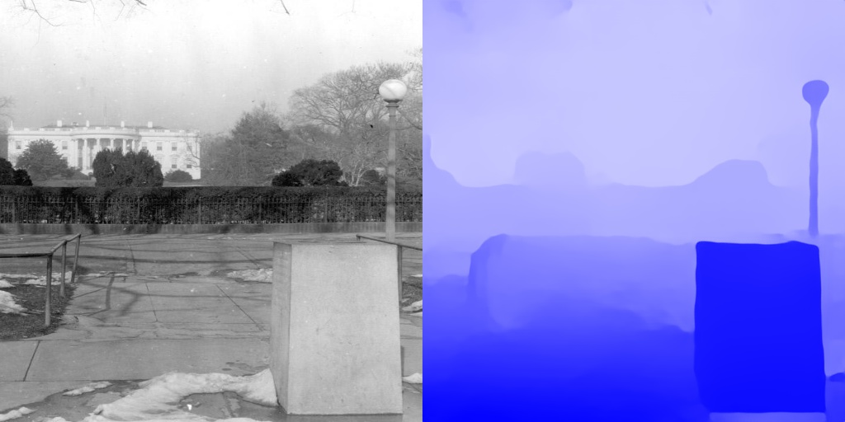

07255.jpg

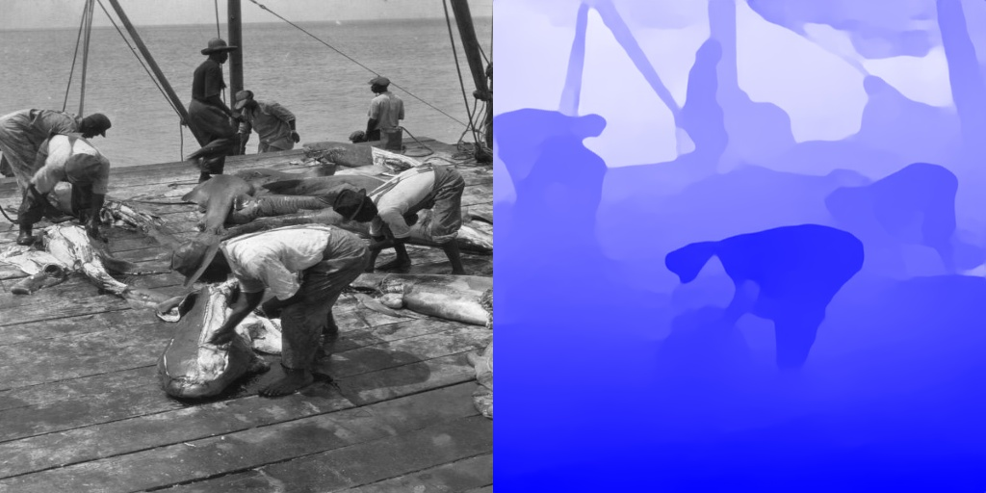

08515.jpg

1. Good -- The Depth Image is consistent with the Color Image even with the light effect or windows/water’s reflection effect
2. Consistent depth match

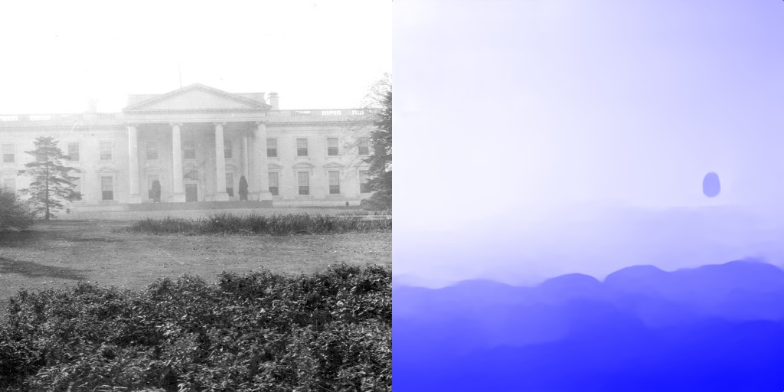

07251.jpg

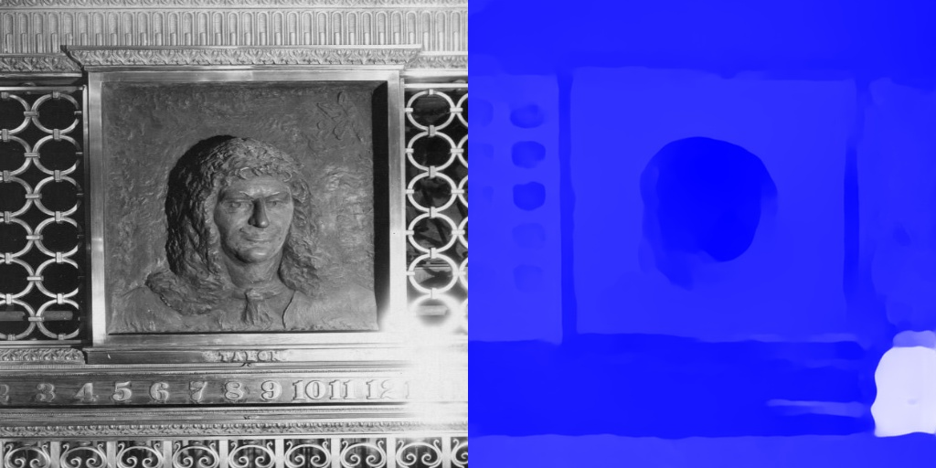

08651.jpg

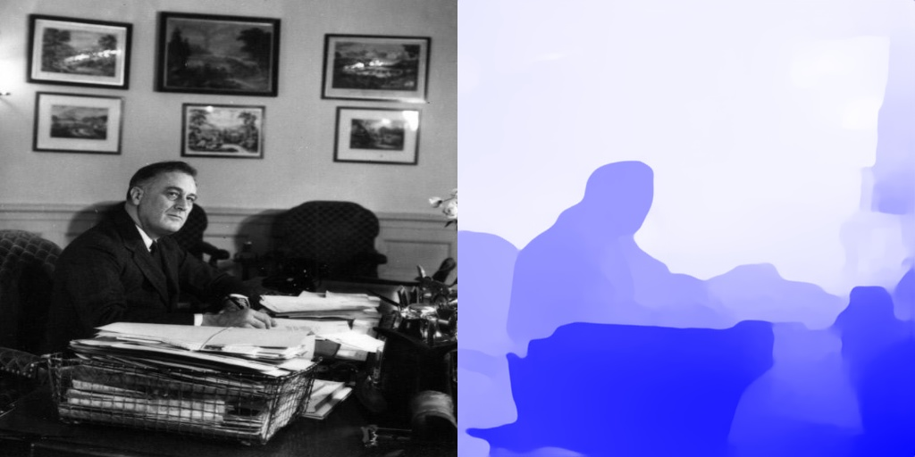

07311.jpg

1. Consistent Mirror’s reflection effect

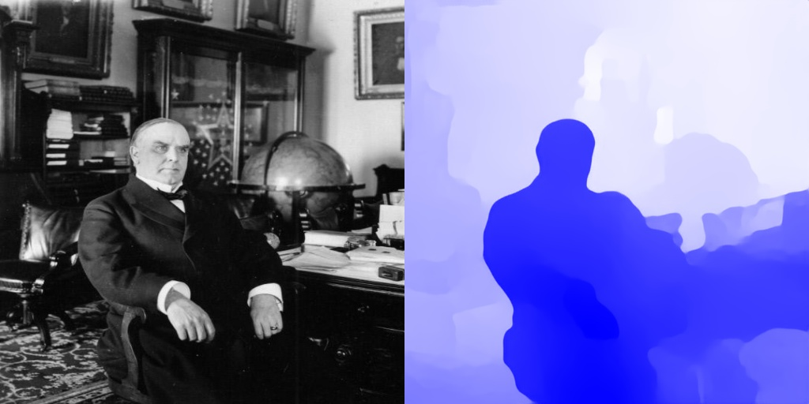

07067.jpg

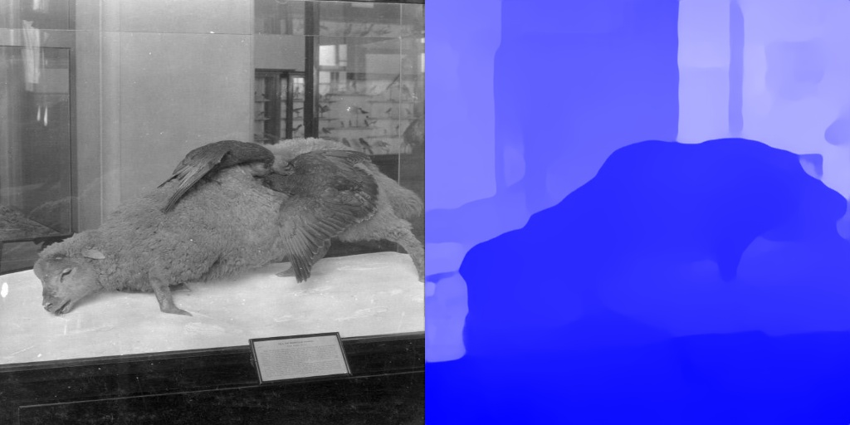

07029.jpg

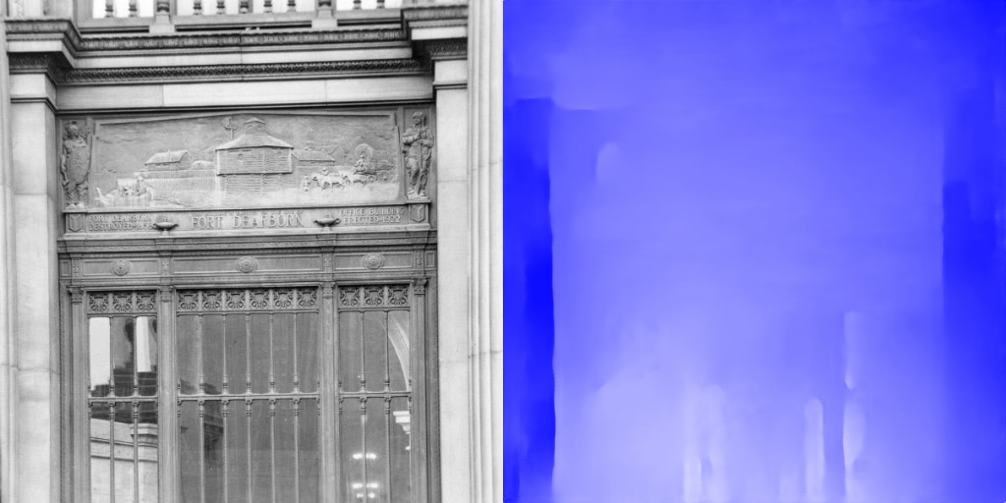

09083.jpg

1. Consistent Water’s reflection effect

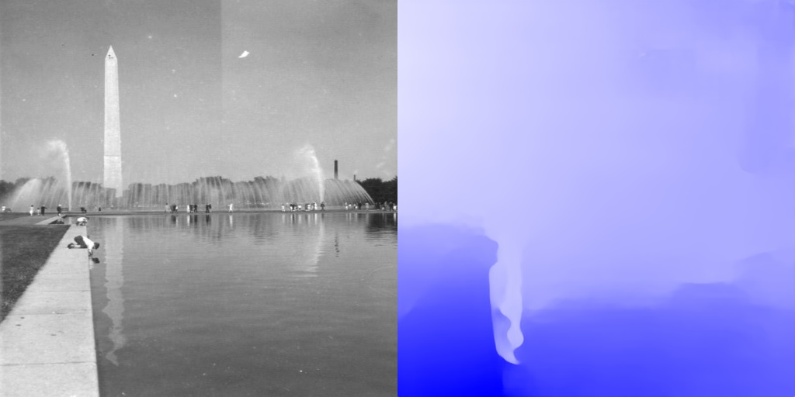

07367.jpg

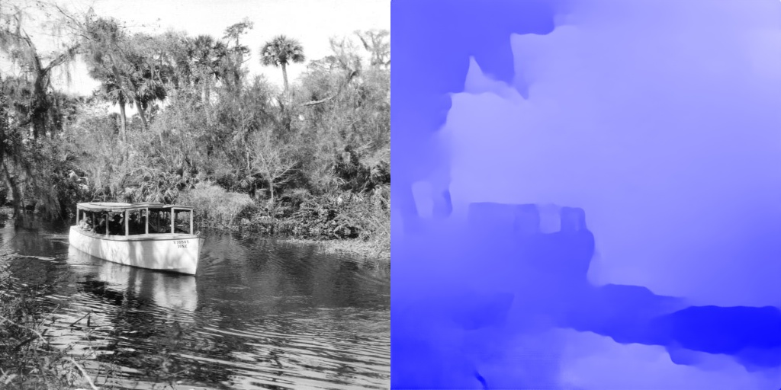

08427.jpg

1. Smooth outline

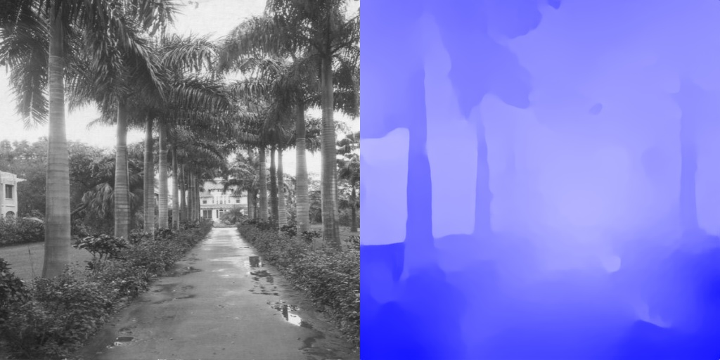

07981.jpg

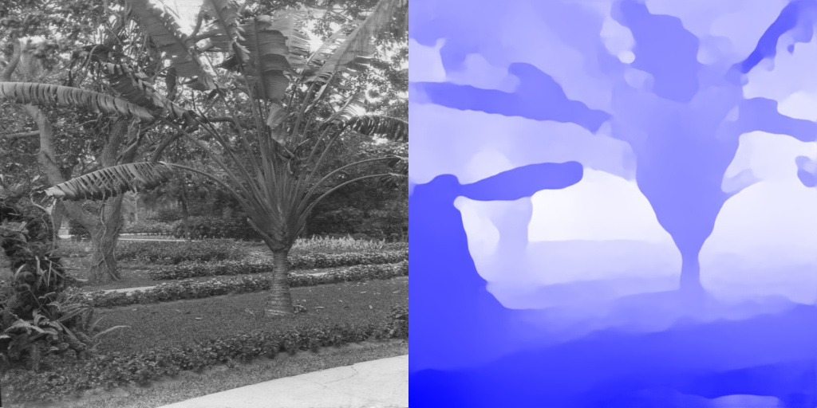

08077.jpg

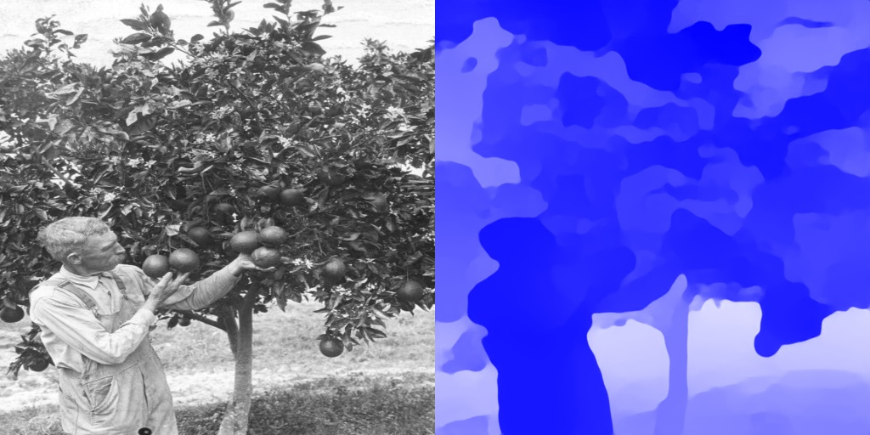

08501.jpg

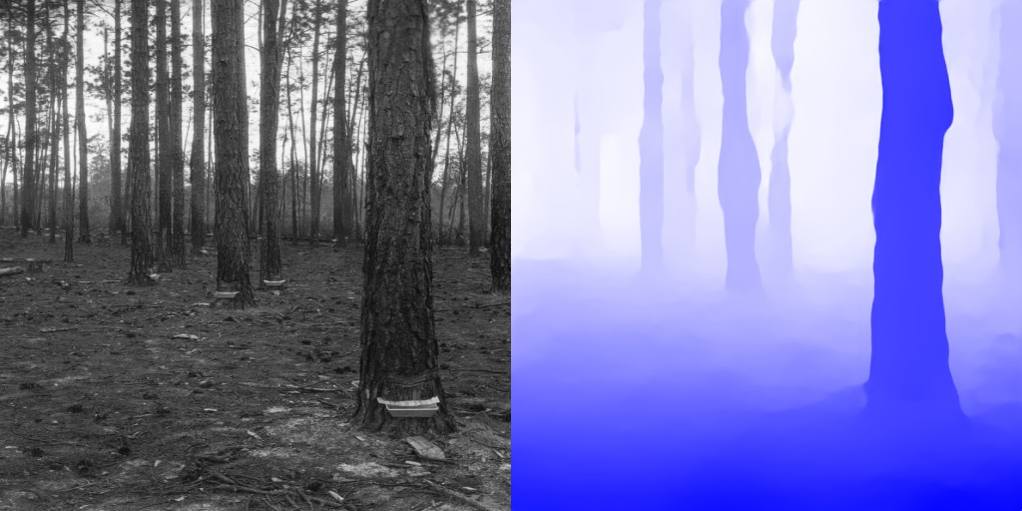

08547.jpg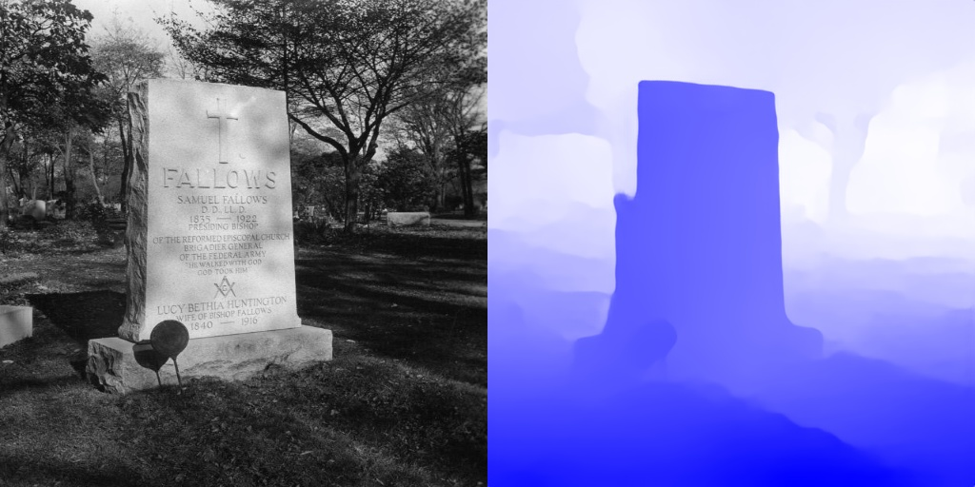

08569.jpg